IMU BRAD Station Tracking Software Instructions

Written by: Mathew Clutter

If you are reading this, you likely want to track a balloon using the Montana Space Grant’s BOREALIS program’s ground station. This document will lay out the steps to use the software associated with the ground station to track a balloon.

To launch the GUI, double click on the file called main.exe. This will launch the tracking software.

1. Select or enter your Balloon IMEI in the top left corner
   1. 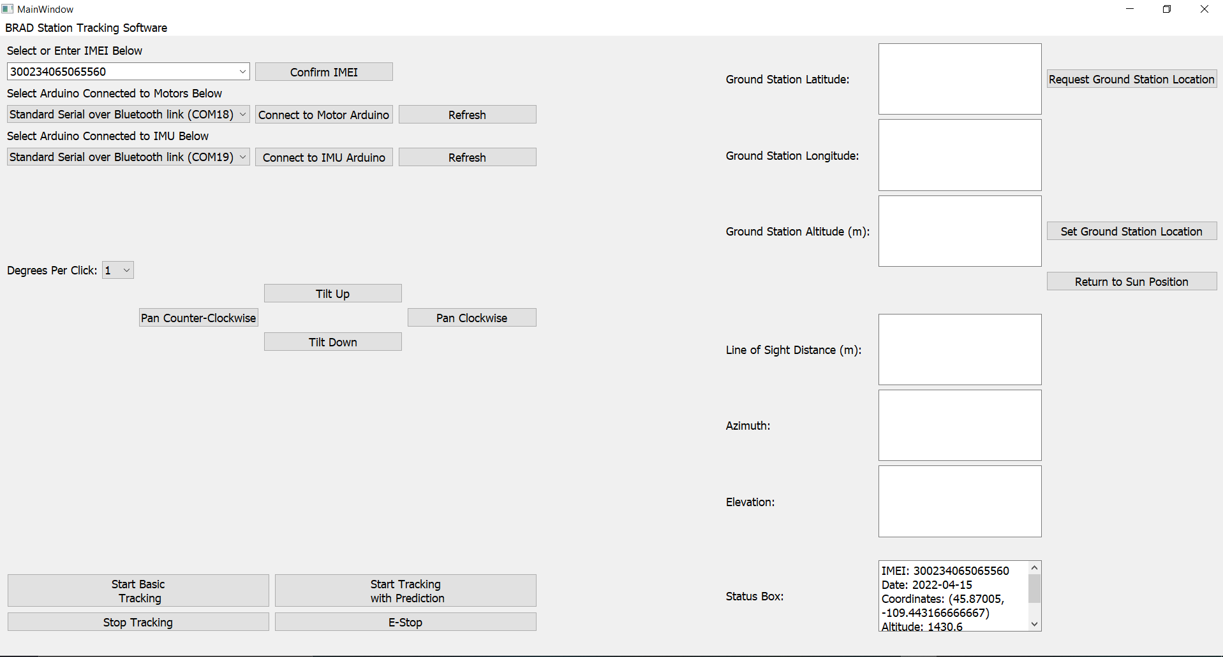
   2. After selecting your balloon’s IMEI, hit the confirm IMEI button.
      1. Ensure that the date in the status box in the bottom right corner is the correct date. If not, the balloon will not be tracked properly.
2. Select and connect the Arduinos in the box below the IMEI selection
   1. Graphical user interface, application

      Description automatically generated
   2. Ensure that the Arduino connected to the ground station is selected and press the “Connect to Arduino” button.
      1. If you have not yet connected the Arduino on the ground station, plug in the Arduino and then git the Refresh button. This will find the Arduino.
   3. Connect the IMU Arduino to the software.
      1. Complete the same process for the Arduino connected to the IMU.
3. Obtain the GPS location of the Ground Station setup
   1. Enter the location of the ground station in the boxes in the top right corner.
      1. Graphical user interface, application

         Description automatically generated
         1. After obtaining/entering the location of the ground station, hit the “Set Ground Station Location” button.
4. Hit the “Start Tracking” button in the bottom left to begin tracking the balloon!
   1. Basic tracking will simply point the antenna at the last position reported by the Iridium. Tracking with prediction will attempt a more precise tracking by extrapolating the change in position between previous Iridium pings, to continue adjusting the pointing of the antenna between pings of the Iridium.
   2. The “Stop Tracking” button will end the tracking
      1. The E-Stop button will immediately stop the motors, not allowing them to finish their last command.
      2. A screenshot of a computer

         Description automatically generated

Other items to note:

* Internet connection is required to run the ground station tracker.
  + This is due to the balloon position coming from the web server.
* Ensure that your Iridium is on and actively pinging the server before starting tracking.
  + <https://borealis.rci.montana.edu/tracking>
* Additional information and error messages will appear in the bottom right corner in the status box. If something is not working, this may help you to debug what the issue is.
* The tracker is designed to work with Windows. If you have the desire to play with serial ports, and potentially other issues, it shouldn’t be too hard to port to OSX or Linux if you so desire.
  + The python source code is provided, and will function (on Windows), assuming you install all of the dependencies needed.
* If you have two monitors connected when running the tracker, you may need to resize the window to get it to scale correctly.
* This software is still being developed, so it is very likely that there are bugs that have not yet been found. Please inform me if you have any problems using this software!
  + If you have any other questions or concerns, contact me at: [mathewclutter@gmail.com](mailto:mathewclutter@gmail.com)